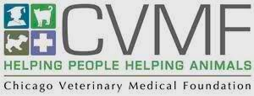

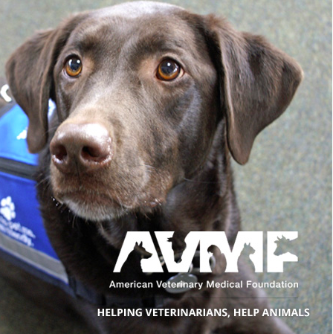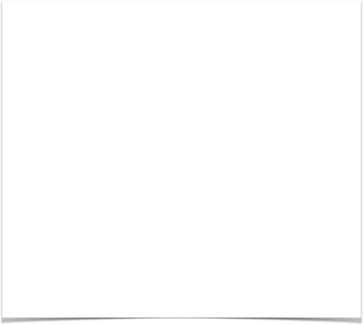

2nd Annual Carol Stream Animal Hospital

Charity Dog Show

Net proceeds benefit the CVMF & AVMF Veterinary Care Charitable Fund®”

Carol Stream Town Center

10am - 4pm

# We would like to welcome everyone to the “2*nd* Annual Carol Stream Animal Hospital Charity Dog Show.” This fun event will be held September 22nd from 10am - 4pm at the community Town Center in Carol Stream. We will have a lot of fun events for pets to participate in and win a variety of prizes. We want to show off the best dogs in Illinois. This event will directly help pet owners of our community with any hardships that they may be undergoing. Please consider either participating in one of the fun events, making a charitable donation, or simply attending the event and supporting our causes. For more information please visit our website [carolstreamah.com](http://carolstreamah.com).

[CarolStreamah.com](http://CarolStreamah.com)

22

September

